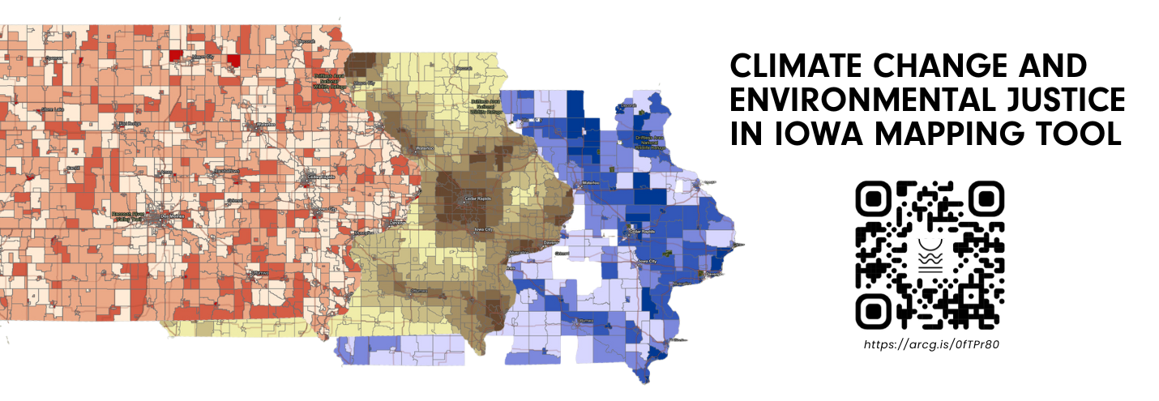

Interactive Map: Exploring Climate Change and Environmental Justice in Iowa
User Guide and Tips to Ensure Functionality
Faster Loading Speed
- User tip: When the map first opens, give it a second to load the 50 different layers of data within it. There’s a lot of information there!
- User tip: Once the map loads, click the “Toggle Layers” widget in the top left of your screen under the address bar to see a full list of map layers containing key information.
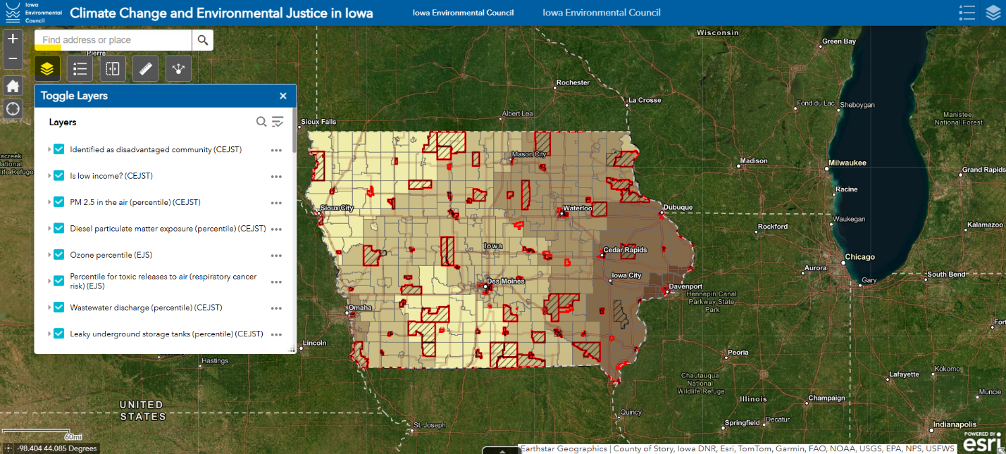
- User tip: For faster loading and to isolate individual layers, click the icon that looks like three bars with a check mark laid across them in the “Toggle Layers” window and select “Turn all layers off.” You can find it next to magnifying glass. Once selected, all layers will be turned off, allowing for faster rendering and allowing you to select which layers you want to view.
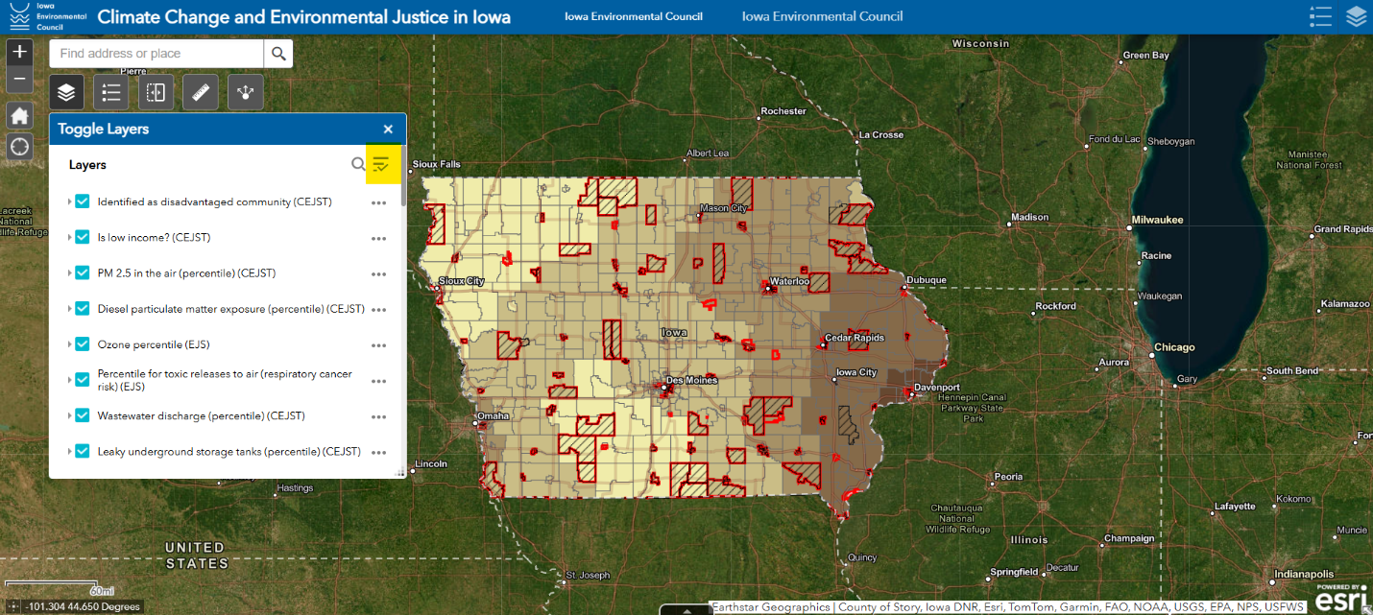
Viewing Layers
- User tip: The layers are stacked upon one another, meaning the layer on the top of the stack that is turned on is the one you will be viewing. Think of it as a sandwich—if the bun is on top, you can’t see the lettuce.
- User tip: The top two layers, “Identified as a disadvantaged community (CEJST)” and “Is low income (CEJST)” are transparent, meaning they can be overlaid on an underlying layer to show the relationship between being considered a disadvantaged community, being a low-income community, and the third layer you select. For example, if you have those first two layers on and then select “PM 2.5 in the air (percentile) (CEJST)” you can see which communities are classified as disadvantaged, are low-income, AND rank in the upper percentiles for PM 2.5 pollution in the air.
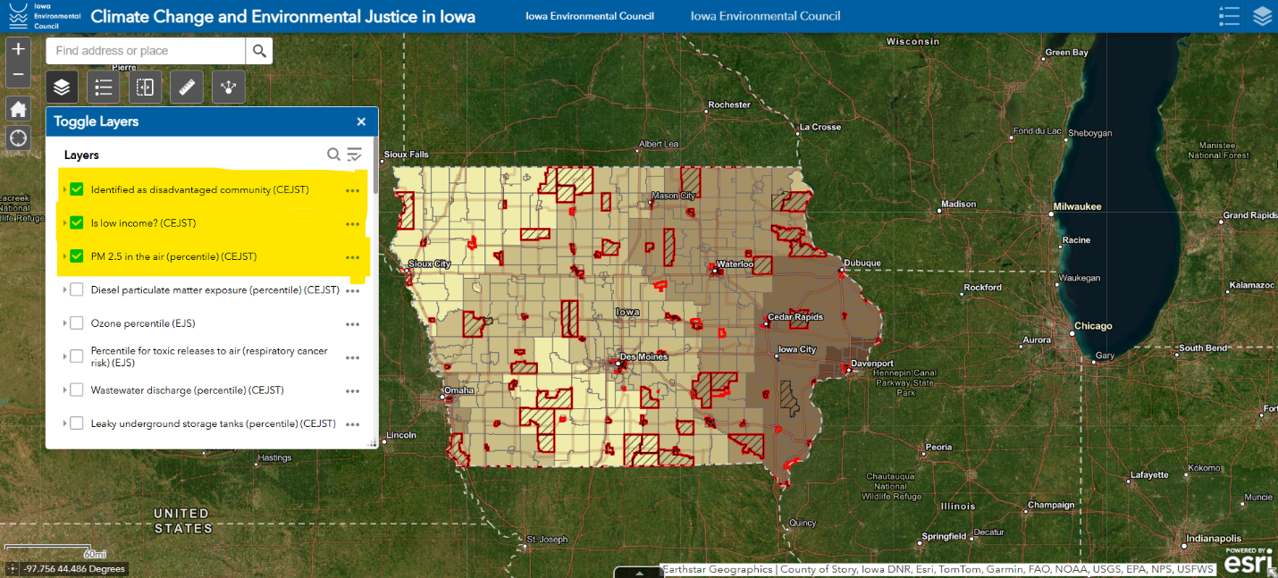
- User tip: For every layer, the first row of data that is shown in the list contains the information about the layer. The names can be a little misleading but be assured that the first row in the pop-up window contains the information of the layer you have selected. If you’d like to see the full name and description of the layer you’re viewing, view the EJ Map Codebook below or download it here.
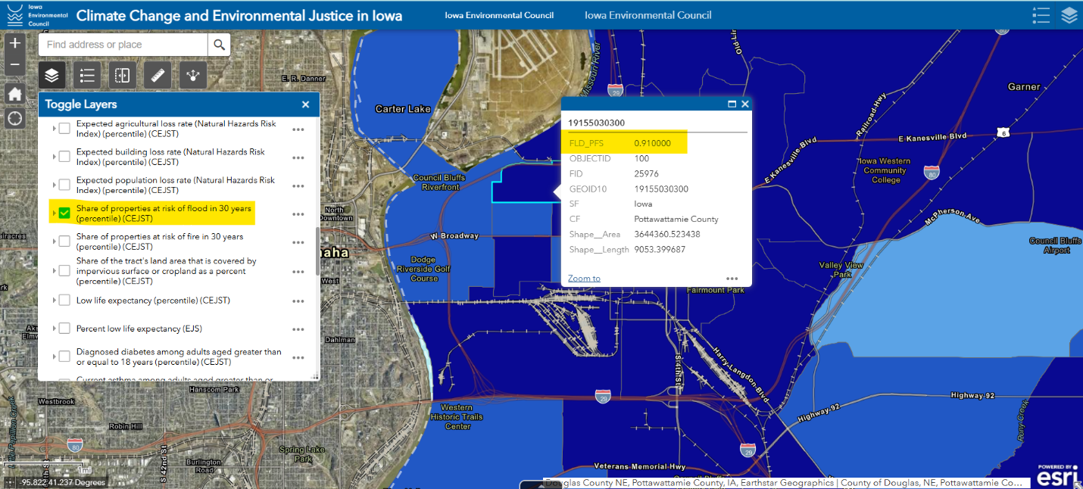
Layer Categorization and Legends
- User tip: The layers are categorized in groups by order. The top two layers, as described above, are helpful for connecting environmental pollution and climate vulnerabilities to economic disadvantages and marginalized populations. The rest of the layers follow a categorization by group in order of:
  - Group 1: Pollution Risks
  - Group 2: Environmental Justice Burdens
  - Group 3: Climate Vulnerabilities
  - Group 4: Health Disparities
  - Group 5: Demographic Information
  - Group 5: Economic Disadvantages

- User tip: To view the legend for your layer, simply click on its name within the “Toggle Layers” window and it will expand.
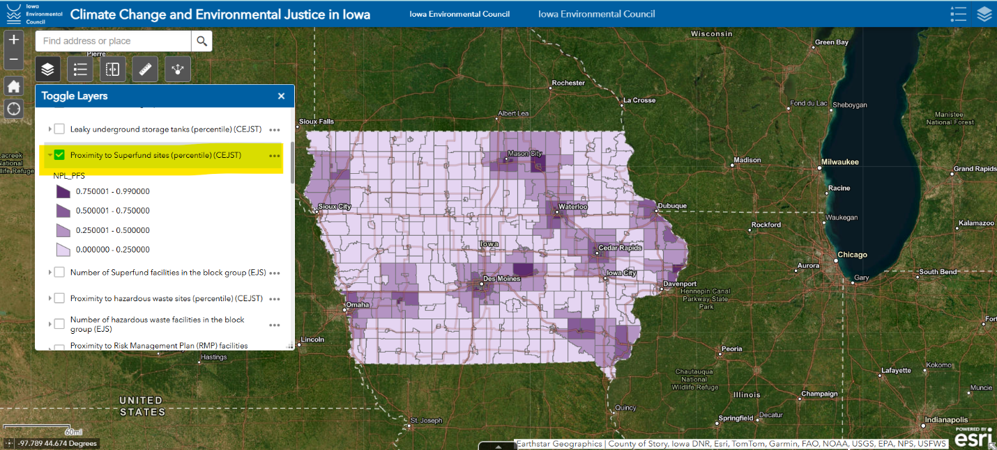
Tools and Functionality
- User tip: To view this information in your community, or even at your home address, school, or place of work, simply use the “Find address or place” search function. You can enter a city name, zip code, street address, or county and the map will zoom to that location.
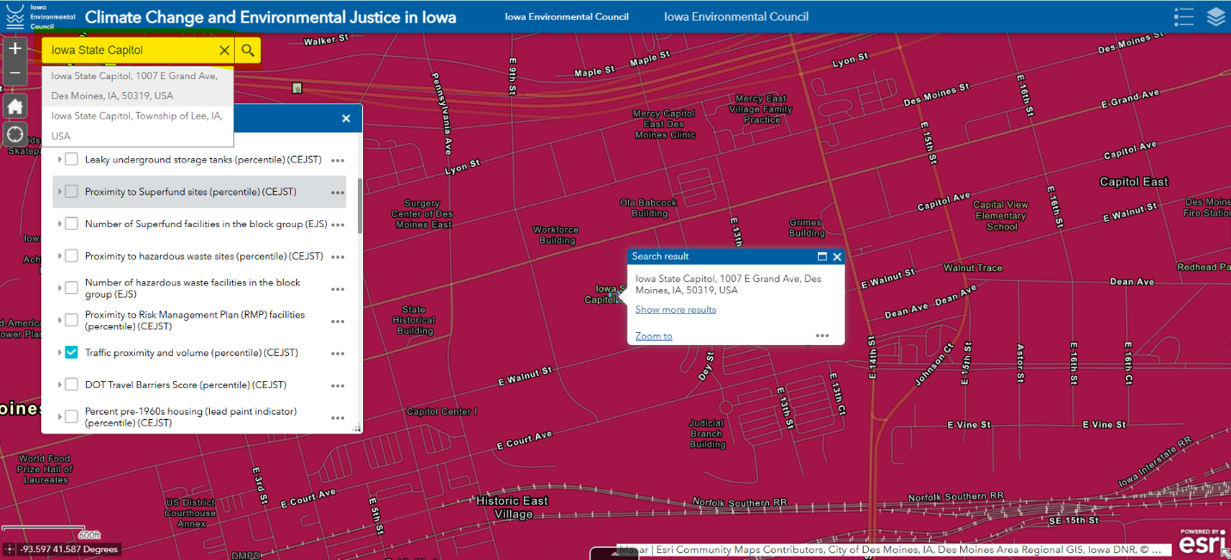
- User tip: This map comes equipped with tools you can use to increase its functionality in your learning and work. For example, there is a measurement tool that allows you to measure the distance (in miles) between a census block group with a Superfund site (or any other featured layer) and a community amenity, such as a public pool as shown here. This tool also allows you to draw a polygon onto the map that tells you how big the area you drew is (in acres).
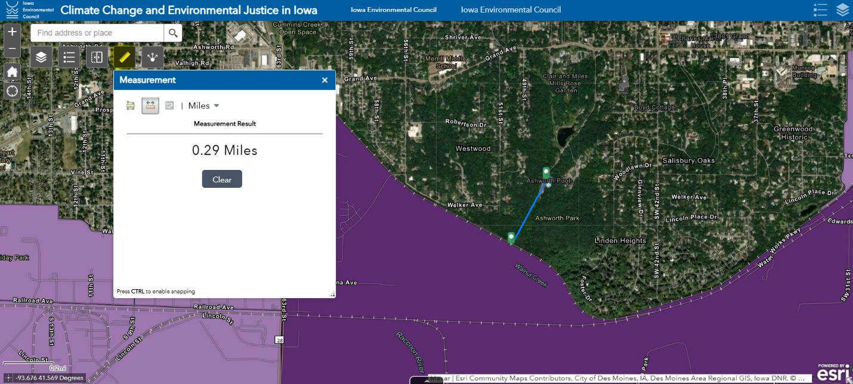
- User tip: This map is also equipped with a swipe tool. This tool allows you to swipe away one layer while leaving another one visible. Simply select the “Swipe Layer” widget and select which layer you would like to be swipeable from the list of map layers. For this to work most effectively, you should have at least two layers visible on the map. This tool can be used to demonstrate the relationship between any two layers, such as a census tract that was historically redlined and the prevalence of health conditions such as coronary heart disease.
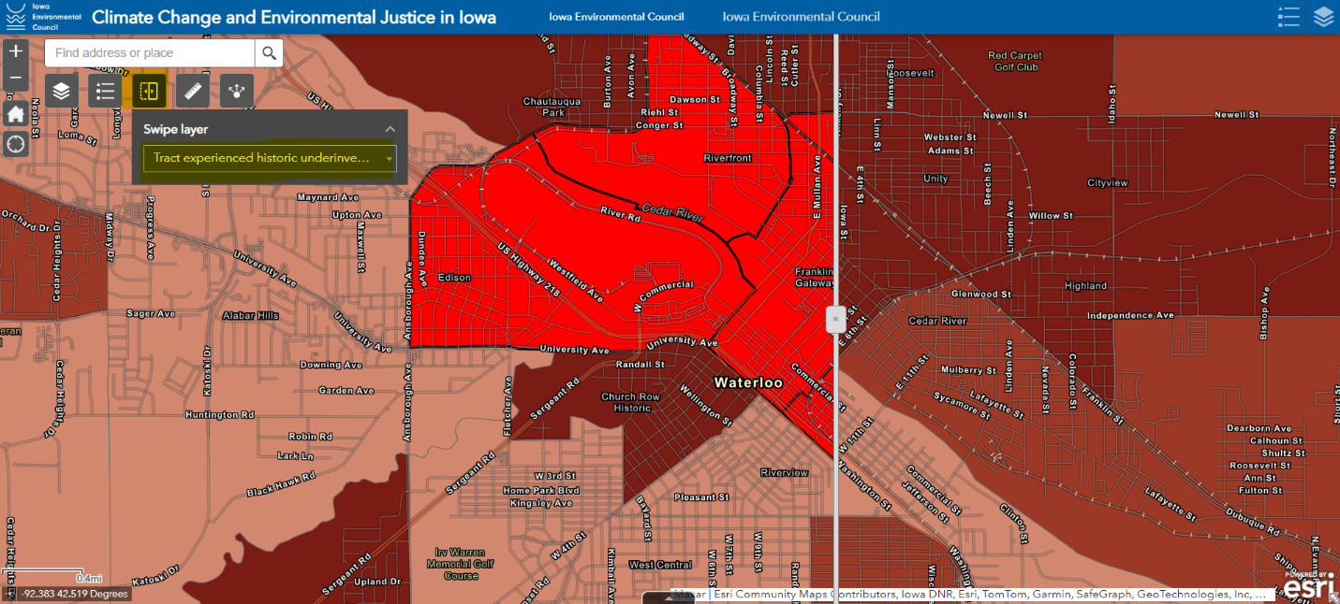
- User tip: You can share this map in a variety of ways by simply clicking the “Share” widget. This widget will bring up a window with a link you can copy and paste in an email, text, or on social media. If you want to share a link that is already zoomed into the location you’d like, click “Link options” just below the link and select “Click the map to define the center of the map with zoom level.” This will update your link to zoom into your selected zoom level when you share it, highlighting a city, home, or other location.
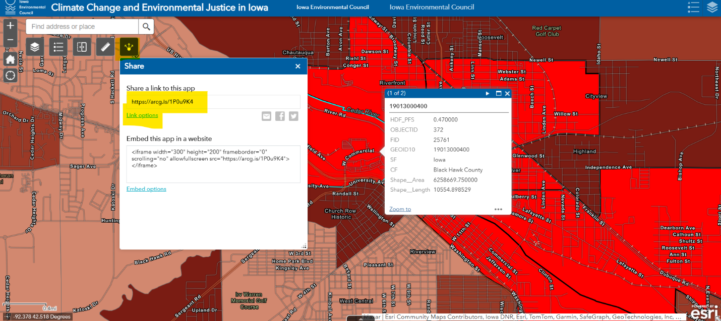
Background Information and Data Sources
Every layer featured on this map came from either the Council on Environmental Quality’s Climate and Economic Justice Screening Tool (CEJST) or the U.S. Environmental Protection Agency’s EJ Screen (EJS) map. On Jan. 22, 2025, CEJST was removed from the federal webpage that hosted it, but it is now available here. EJS can be accessed here.
To further explain the definitions and categorization of this climate change, health, environmental justice, demographic, and economic information, IEC created an IEC EJ Map Codebook that you can download here.

